The main goal of most soil improvement techniques used for reducing liquefaction hazards is to avoid large increases in pore water pressure during earthquake shaking. This can be achieved by densification of the soil and/or improvement of its drainage capacity.
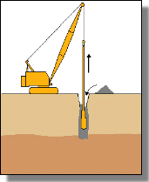
Vibroflotation
Vibroflotation involves the use of a vibrating probe that can penetrate granular soil to depths of over 100 feet. The vibrations of the probe cause the grain structure to collapse thereby densifying the soil surrounding the probe. To treat an area of potentially liquefiable soil, the vibroflot is raised and lowered in a grid pattern. Vibro Replacement (right, HB) is a combination of vibroflotation with a gravel backfill resulting in stone columns, which not only increases the amount of densificton, but provides a degree of reinforcement and a potentially effective means of drainage.

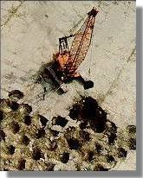
Dynamic Compaction
Densifiction by dynamic compaction is performed by dropping a heavy weight of steel or concrete in a grid pattern from heights of 30 to 100 ft. It provides an economical way of improving soil for mitigation of liquefaction hazards. Local liquefaction can be initiated beneath the drop point making it easier for the sand grains to densify. When the excess porewater pressure from the dynamic loading dissipates, additional densification occurs. As illustrated in the photograph, however, the process is somewhat invasive; the surface of the soil may require shallow compaction with possible addition of granular fill following dynamic compaction.
Stone Columns
As described above, stone columns are columns of gravel constructed in the ground. Stone columns can be constructed by the vibroflotation method. They can also be installed in other ways, for example, with help of a steel casing and a drop hammer as in the Franki Method. In this approach the steel casing is driven in to the soil and gravel is filled in from the top and tamped with a drop hammer as the steel casing is successively withdrawn.
Compaction Piles
Installing compaction piles is a very effective way of improving soil. Compaction piles are usually made of prestressed concrete or timber. Installation of compaction piles both densifies and reinforces the soil. The piles are generally installed in a grid pattern and are generally driven to depth of up to 60 ft.
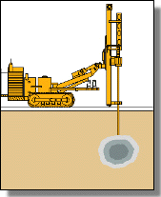
Compaction Grouting
Compaction grouting is a technique whereby a slow-flowing water/sand/cement mix is injected under pressure into a granular soil. The grout forms a bulb that displaces and hence densifies, the surrounding soil (right, HB). Compaction grouting is a good option if the foundation of an existing building requires improvement, since it is possible to inject the grout from the side or at an inclined angle to reach beneath the building.

Drainage techniques
Liquefaction hazards can be reduced by increasing the drainage ability of the soil. If the porewater within the soil can drain freely, the build-up of excess pore water pressure will be reduced. Drainage techniques include installation of drains of gravel, sand or synthetic materials. Synthetic wick drains can be installed at various angles, in contrast to gravel or sand drains that are usually installed vertically. Drainage techniques are often used in combination with other types of soil improvement techniques for more effective liquefaction hazard reduction.

Verification of Improvement
A number of methods can be used to verify the effectiveness of soil improvement. In-situ techniques are popular because of the limitations of many laboratory techniques. Usually, in-situ test are performed to evaluate the liquefaction potential of a soil deposit before the improvement was attempted. With the knowledge of the existing ground characteristics, one can then specify a necessary level of improvement in terms of insitu test parameters. Performing in-situ tests after improvement has been completed allows one to decide if the degree of improvement was satisfactory. In some cases, the extent of the improvement is not reflected in in-situ test results until some time after the improvement has been completed

